**Facial Feature Extraction for project**

The dlib library is a powerful tool for performing facial feature extraction in python. It’s a landmark’s facial detector with per-trained models, the dlib is used to estimate the location of 68 coordinates (x,y) that map the facial point on a person’s face like image(Fig 4) below.These points are identified from the pre-trained model where IBUG300-W dataset was used.



Fig 1: Facial Feature points

* The Locations of the Facial parts are as follows:

1. The Jawline is accessed with points [0,16]
2. The Right eyebrow is accessed with points [17,21]
3. The left eyebrow is accessed with points [22,26]
4. The nose is accessed with points [27,35]
5. The Right eye is accessed with point [36,41]
6. The left eye is accessed with points [42,47]
7. The Mouth is accessed with points [48, 67]

Once a face is detected , the dlib library uses a per-trained facial landmark predictor to extract the facial features. The landmark predictor is a machine learning model that has been trained on a large dataset of labeled facial images.it takes as input an image patch around a detected face and outputs the coordinates of various facial landmarks, such as the corners of the eyes, nose, mouth, and eyebrows, among others as shown in figure 5.

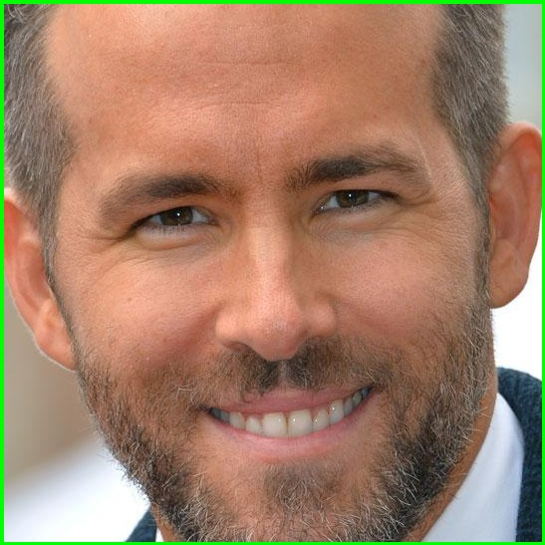 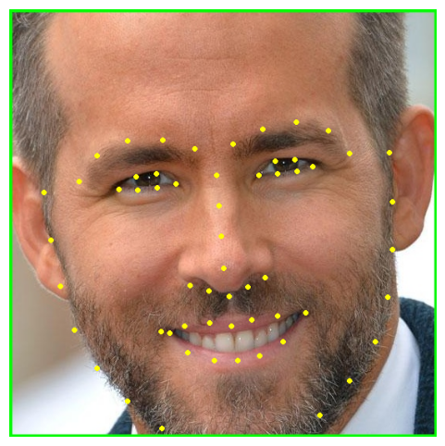

Fig 2 Landmark Feature Points

The landmark predictor uses a technique called shape prediction, which involves fitting a set of predefined shapes to the input image patch.the predefined shapes are generated by clustering a large number of facial landmark coordinates from the training dataset. The landmark predictor then uses a regression model to adjust the position of the predefined shape to fit the input image patch. The resulting shape is used to extract the facial features.

The dlib library provides a convenient interface for performing facial feature extraction in python. The library can be used to detect and extract their facial features in real-time video streams or static images. The extracted features can be used for various tasks, such as face recognition, emotion detection and facial expression analysis.